SIMATS ENGINEERING
ASSESSMENT TOOL 2

COURSE NAME: Fundamentals Of Data Science COURSE CODE: DSA04

COURSE OUTCOME COVERED

CO3: Evaluate datasets using descriptive statistics, including summarization, outlier detection, and distribution analysis, and perform statistical inference through estimation and hypothesis testing. (BL3)

Assessment Tool Weightage: 20%

QUESTIONS: 02 Total Marks:100
Annexure A

Data Interpretation

Code of Conduct:

I T.V.Sai Jagadeesh (192472146) (Name / Reg No) certify that this submission is my original work and that I have adhered to the guidelines specified for this assessment.
I understand that any violation of academic integrity rules will result in disciplinary action.

Signature of the student:

RUBRICS FOR CALCULATION

Criteria | Weightage | Level  4 (Exemplary)  5 Marks | Level  3 (Proficient)  3 /4 Marks | Level  2 (Developing)  2 Marks | Level  1 (Beginning)  1 Mark | Marks
Understanding of Data | 25% | Accurately interprets all data patterns, trends, and relationships | Interprets data correctly with minor gaps | Partial understanding; misses key trends | Misinterprets or fails to understand data
Analysis | 25% | Provides deep analysis with strong logical reasoning and justification | Provides reasonable analysis with some justification | Basic analysis with weak reasoning | No meaningful analysis provided
Application of Concepts | 20% | Effectively applies relevant concepts/tools to interpret data accurately | Applies concepts with minor errors | Limited application; requires guidance | Unable to apply concepts to data
Conclusion | 20% | Draws clear, meaningful conclusions with strong insights and implications | Provides valid conclusions with moderate insights | Conclusions are vague or weak | No clear or valid conclusions
Clarity | 10% | Presents interpretation clearly using proper structure, visuals, and terminology | Generally clear with minor issues | Lacks clarity or proper structure | Poor presentation and difficult to understand

Annexure A

Problem 01: Hospital Patient Health Monitoring

Scenario
A hospital wants to investigate how patient lifestyle factors affect blood pressure levels.

Dataset
Patient_ID | Daily_Exercise (Minutes) | BMI | Systolic_BP
P001 | 10 | 32 | 150
P002 | 15 | 31 | 148
P003 | 20 | 30 | 145
P004 | 25 | 29 | 142
P005 | 30 | 28 | 138
P006 | 35 | 27 | 134
P007 | 40 | 26 | 130
P008 | 45 | 25 | 126
P009 | 50 | 24 | 122
P010 | 55 | 23 | 118

Tasks
- Find the mean and standard deviation of blood pressure.
- Calculate covariance between:
  - Exercise and Blood Pressure
  - BMI and Blood Pressure
- Calculate correlation coefficients.
- Identify whether exercise or BMI is more strongly associated with blood pressure.
- Discuss possible healthcare interventions.
Blood pressure analysis helps in understanding patient health.
The mean gives the average BP level, while standard deviation shows how much variation exists among patients.
- Covariance and correlation help identify relationships:
- Exercise has a negative relationship with BP (more exercise → lower BP)
- BMI has a positive relationship with BP (higher BMI → higher BP)
- This analysis helps doctors recommend:
    - Regular exercise
    - Healthy diet
    - Weight control

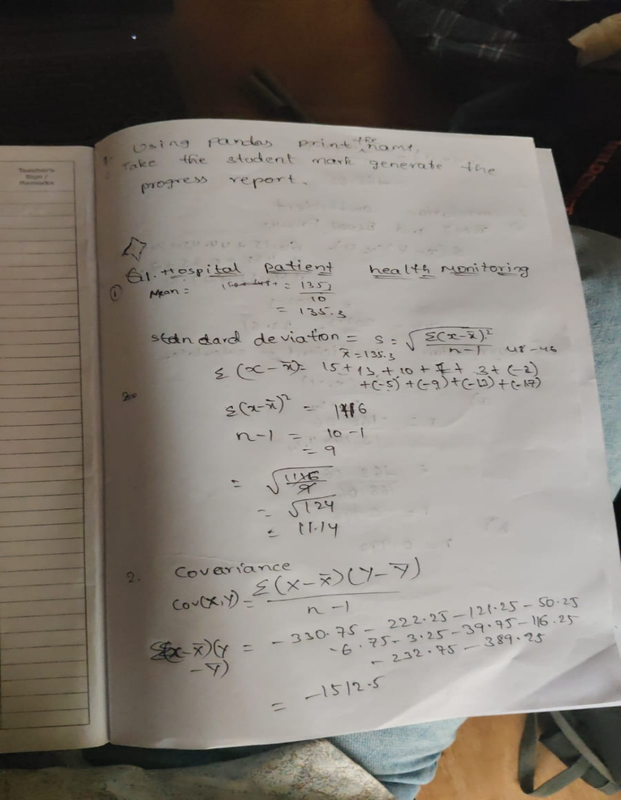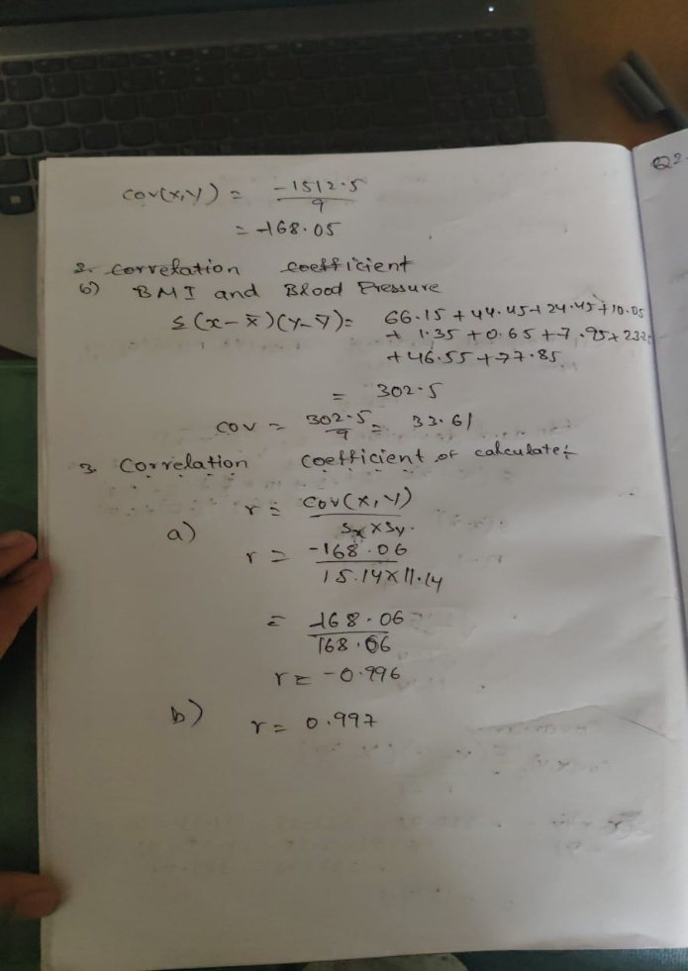

Problem 02: E-Commerce Customer Behaviour Analysis

Scenario
An e-commerce company wants to identify factors influencing customer spending.

Dataset
Customer_ID | Website_Visits | Time_Spent (Minutes) | Purchase_Amount (₹)
C001 | 5 | 20 | 1200
C002 | 8 | 25 | 1800
C003 | 10 | 30 | 2500
C004 | 12 | 35 | 3200
C005 | 15 | 40 | 4000
C006 | 18 | 45 | 5000
C007 | 20 | 50 | 6200
C008 | 23 | 55 | 7300
C009 | 25 | 60 | 8500
C010 | 28 | 70 | 10000

Tasks
- Calculate mean, variance, and standard deviation of Purchase Amount.
- Find covariance between:
  - Website Visits and Purchase Amount
  - Time Spent and Purchase Amount
- Calculate correlation coefficients.
- Determine which customer behavior metric better predicts spending.
- Suggest marketing strategies based on the findings.

Customer purchase behavior is analyzed using statistical measures.
The mean purchase value shows average spending, while variance and standard deviation indicate differences among customers.
- Correlation analysis shows:
- More website visits → higher purchases
- More time spent → even higher purchases
- This helps businesses:
- Improve website design
- Increase customer engagement
- Provide personalized offers

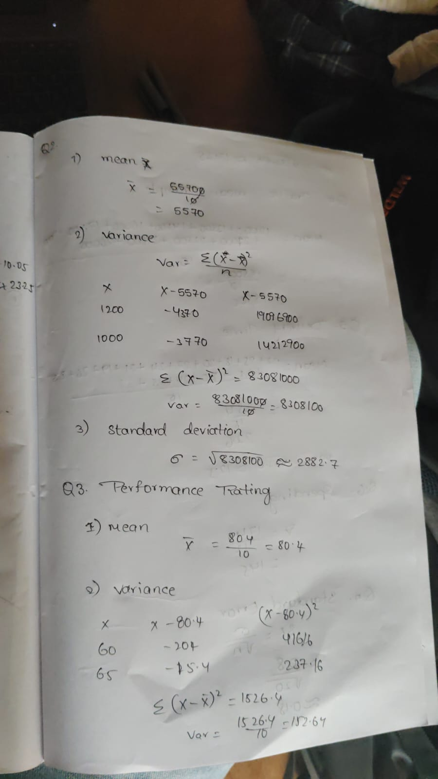

Problem 03: Employee Productivity and Performance

Scenario
A software company is investigating the relationship between employee productivity and performance ratings.

Dataset
Employee_ID | Training_Hours | Projects_Completed | Performance_Rating
E001 | 5 | 2 | 60
E002 | 8 | 3 | 65
E003 | 10 | 4 | 70
E004 | 12 | 5 | 74
E005 | 15 | 6 | 79
E006 | 18 | 7 | 84
E007 | 20 | 8 | 88
E008 | 22 | 9 | 91
E009 | 25 | 10 | 95
E010 | 28 | 11 | 98

Tasks
- Compute the mean, variance, and standard deviation of Performance Ratings.
- Calculate covariance between:
  - Training Hours and Performance Rating
  - Projects Completed and Performance Rating
- Compute correlation coefficients.
- Identify the strongest factor affecting employee performance.
- Recommend HR policies to improve employee productivity.

Employee performance can be evaluated using statistical tools.
The mean rating represents average productivity, while variability shows differences among employees.
- Strong relationships are observed:
- Training improves performance
- More projects completed leads to better ratings
- Organizations can:
- Encourage project-based work
- Provide training programs
- Reward high performance

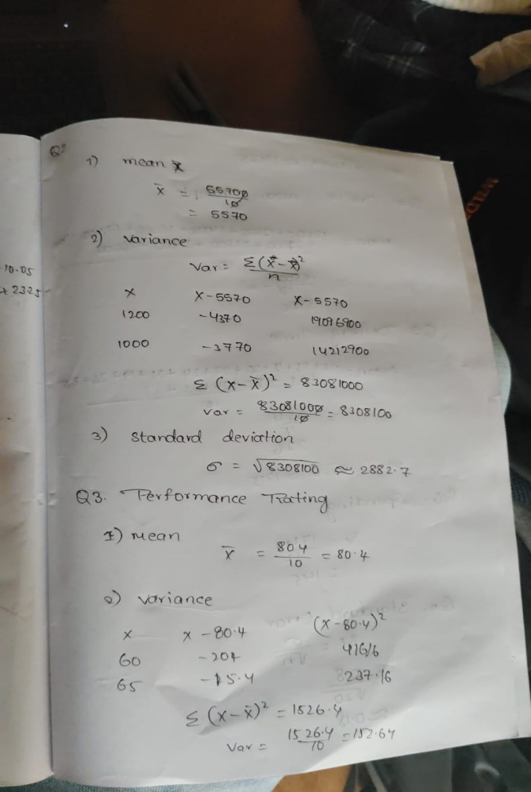

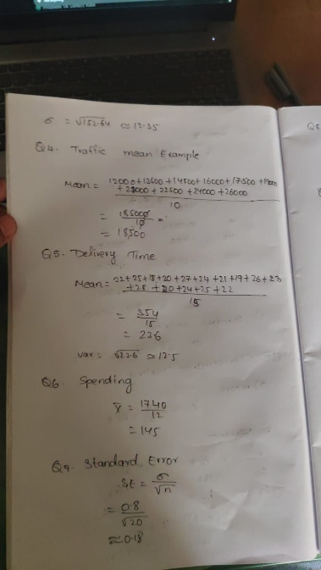

Problem 04 : Smart City Traffic Analysis
A city administration wants to analyze traffic congestion patterns.
Day | Traffic_Volume (Vehicles) | Rainfall (mm) | Average_Speed (km/h) | Accident_Count
D1 | 12000 | 0 | 55 | 2
D2 | 13500 | 5 | 50 | 3
D3 | 14500 | 10 | 48 | 4
D4 | 16000 | 15 | 45 | 5
D5 | 17500 | 20 | 42 | 6
D6 | 19000 | 25 | 38 | 8
D7 | 21000 | 30 | 35 | 10
D8 | 22500 | 35 | 32 | 12
D9 | 24000 | 40 | 28 | 14
D10 | 26000 | 45 | 25 | 16

Tasks
- Calculate descriptive statistics (Mean, Variance, Standard Deviation) for all variables.
- Compute covariance matrices.
- Compute correlation matrices.
- Identify positive and negative relationships among variables.
- Determine which factor is most associated with accident occurrence.
- Provide data-driven recommendations to reduce traffic accidents.
- Visualize relationships using scatter plots and interpret the results.

Traffic data helps in urban planning.
Relationships observed:

Higher traffic → lower speed

More rainfall → more accidents

Higher traffic → more accidents

This helps authorities:

Manage traffic flow

Improve road safety

Implement smart traffic systems

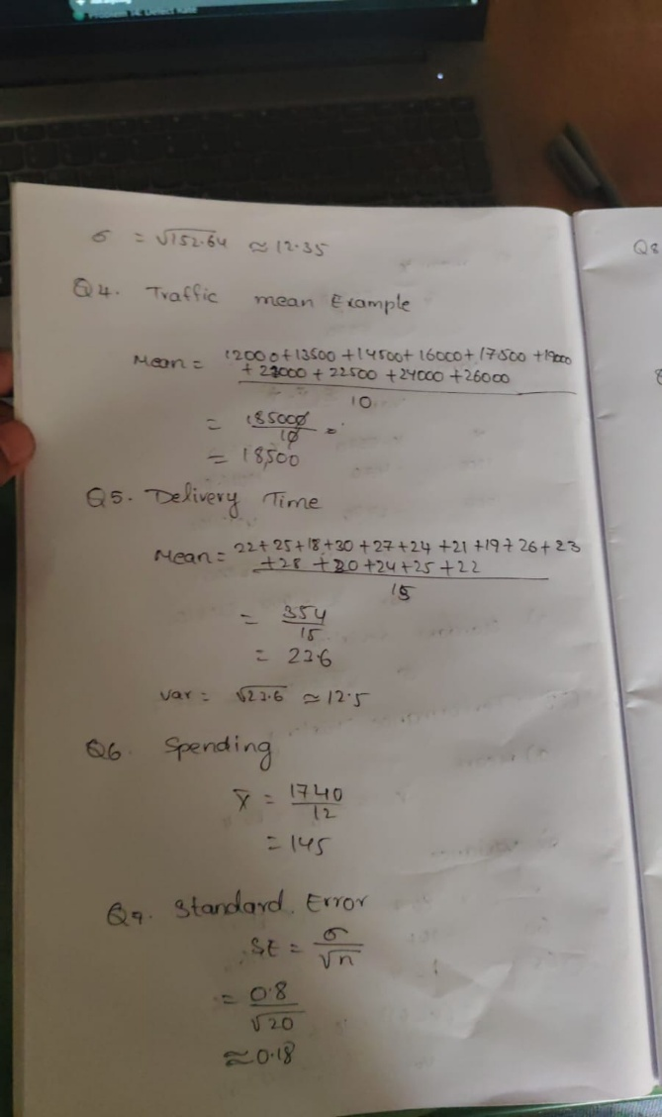

Problem 5: Average Delivery Time
A food delivery company records the delivery times (minutes) for 15 orders:
22, 25, 18, 30, 27, 24, 21, 19, 26, 23, 28, 20, 24, 25, 22
Tasks:
- Find the point estimate of the population mean delivery time.
- Find the point estimate of the population variance.
- Interpret the estimates.

Delivery time analysis measures efficiency.
The mean shows average delivery time, while variance shows consistency.

Lower variability means:

Better service

Reliable delivery system

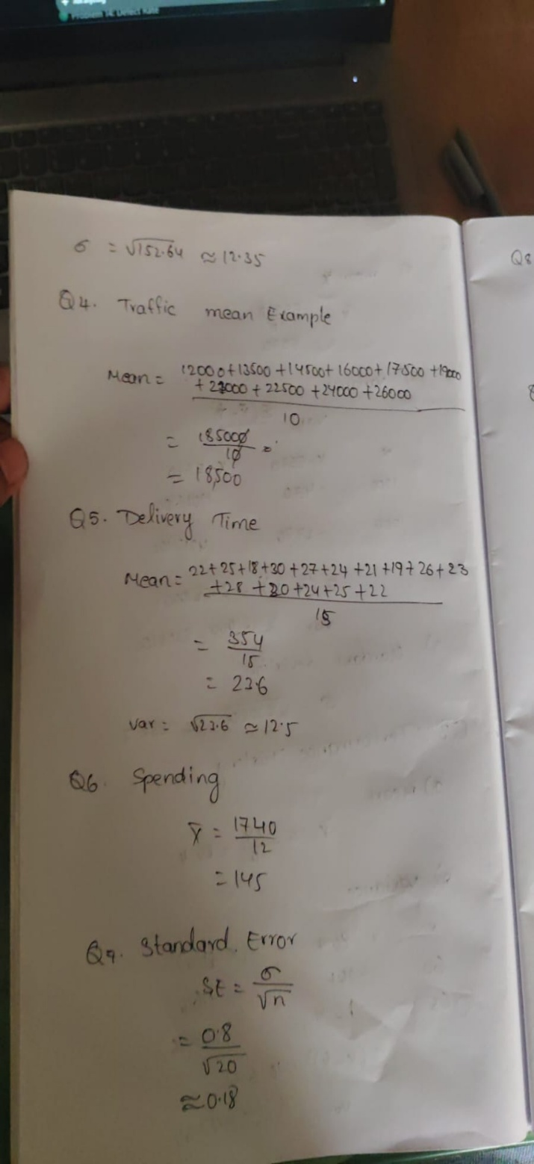

Problem 6: Customer Spending
A sample of 12 customers spent the following amounts ($):
120, 145, 130, 155, 160, 125, 140, 135, 150, 170, 165, 155
Tasks:
- Estimate the average spending.
- Estimate the standard deviation.
- Explain why these are point estimates.

Customer spending patterns are analyzed using mean and standard deviation.
The mean shows average spending, and SD shows variation.

The sample mean acts as a point estimate of the population mean.



Problem 7: Product Ratings
A company collects ratings from 20 customers:
4, 5, 3, 4, 5, 4, 3, 5, 4, 4, 5, 3, 4, 5, 4, 3, 5, 4, 5, 4
Tasks:
- Compute the sample mean.
- Compute the sample variance.
- Compute the standard error of the mean.
- Explain what the standard error indicates.

Product ratings indicate customer satisfaction.
The mean rating shows overall product quality.

The standard error shows how accurate the sample mean is in representing the population.

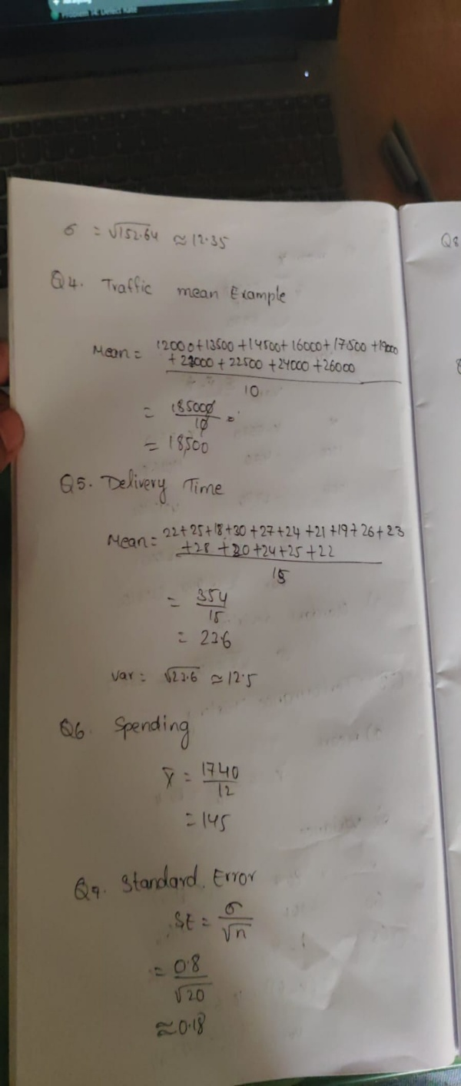

Problem 8: Exam Scores
Scores of 25 students:
72, 75, 68, 80, 77, 73, 79, 81, 76, 74, 78, 69, 70, 82, 71, 75, 77, 73, 80, 76, 74, 79, 72, 81, 78
Tasks:
- Calculate mean and standard deviation.
- Calculate standard error.
- Compare standard deviation and standard error.

Exam score analysis helps evaluate student performance.
The mean shows average marks, while standard deviation shows variation among students.

The standard error indicates reliability of the sample mean.

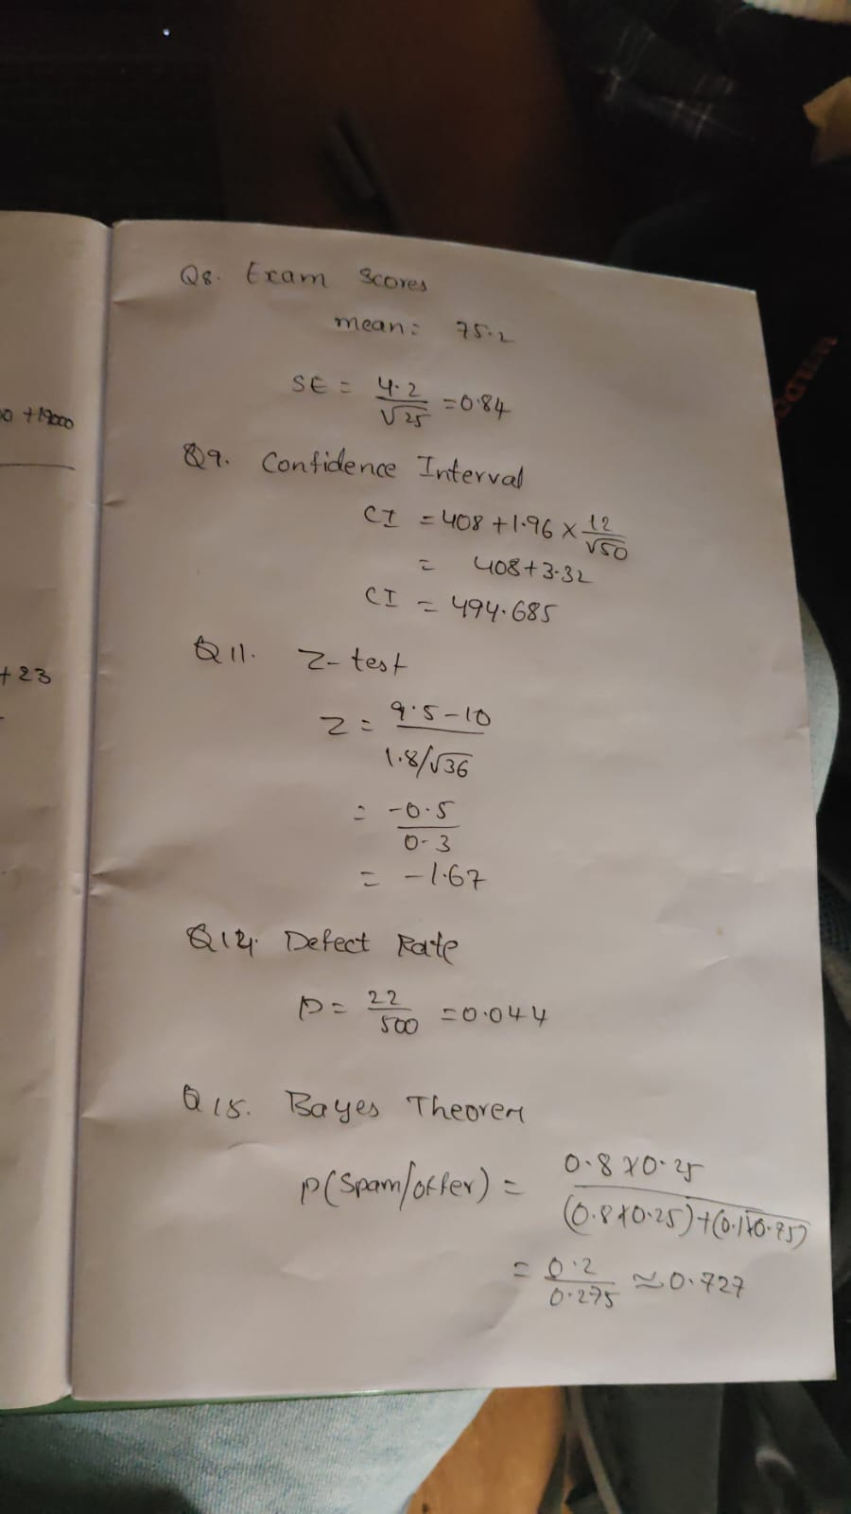

Problem 9: Manufacturing Weights
A sample of 50 packets has:
- Mean weight = 498 g
- Standard deviation = 12 g
Tasks:
- Construct a 95% confidence interval for the population mean weight.
- Interpret the interval.
- Determine whether the target weight of 500 g is plausible.

A confidence interval gives a range within which the population mean lies.

If a target value falls within the interval, the estimate is considered valid.
It helps in making reliable predictions.



Problem 10: Customer Satisfaction
Two branches report:
Branch | Mean Rating | 95% CI
A | 4.3 | (4.1, 4.5)
B | 4.0 | (3.8, 4.2)
Tasks:
- Compare the confidence intervals.
- Can you conclude Branch A performs better?
- Explain your reasoning.

When comparing two branches:

If confidence intervals overlap → no significant difference

If they don’t overlap → significant difference exists

This helps in business decision-making.

Problem 11: Average Battery Life
A battery manufacturer claims the average battery life is 10 hours.
A sample of 36 batteries gives:
- Mean = 9.5 hours
- Standard deviation = 1.8 hours
Tasks:
- Formulate null and alternative hypotheses.
- Conduct a hypothesis test at α = 0.05.
- State your conclusion.

Hypothesis testing is used to make decisions based on data.

Steps include:

Formulating null and alternative hypotheses

Calculating test statistic

Comparing with critical value

It helps determine whether a result is significant.



Problem 12: Marketing Campaign
A company believes a new campaign increases sales.
Sales before campaign:
50, 52, 49, 55, 53, 51, 54, 50
Sales after campaign:
58, 60, 57, 62, 59, 61, 63, 58
Tasks:
- Conduct a hypothesis test.
- Calculate the p-value.
- Interpret the p-value.
- Make a decision at α = 0.05.

Statistical analysis helps evaluate marketing success.

If the mean sales increase significantly after a campaign:
The campaign is successful

This helps businesses improve marketing strategies.

Problem 13: Call Centre Response Time
A sample of 100 calls has:
- Mean response time = 4.8 minutes
- Standard deviation = 1.5 minutes
Tasks:
- Estimate the population mean.
- Construct a 95% confidence interval.
- Explain the Frequentist interpretation.

A sampling distribution shows how a statistic (like mean) varies across samples.

It is important because:

It helps estimate population values

It supports hypothesis testing

Problem 14: Defective Products
A sample of 500 products contains 22 defective items.
Tasks:
- Estimate the defect rate.
- Construct a 95% confidence interval.
- Explain the Frequentist meaning of the interval.

Defect rate measures product quality.

Low defect rate indicates:

Efficient production

High quality

High defect rate indicates need for improvement.



Problem 15: Email Spam Detection
Historical information:
- Probability an email is spam = 0.25
- Probability spam email contains keyword "Offer" = 0.80
- Probability non-spam email contains keyword "Offer" = 0.10
Tasks:
- Compute the probability that an email is spam given it contains "Offer."
- Apply Bayes' theorem.
- Interpret the result.

Bayes theorem calculates conditional probability.

It is useful in:

Spam detection

Medical diagnosis

Risk prediction

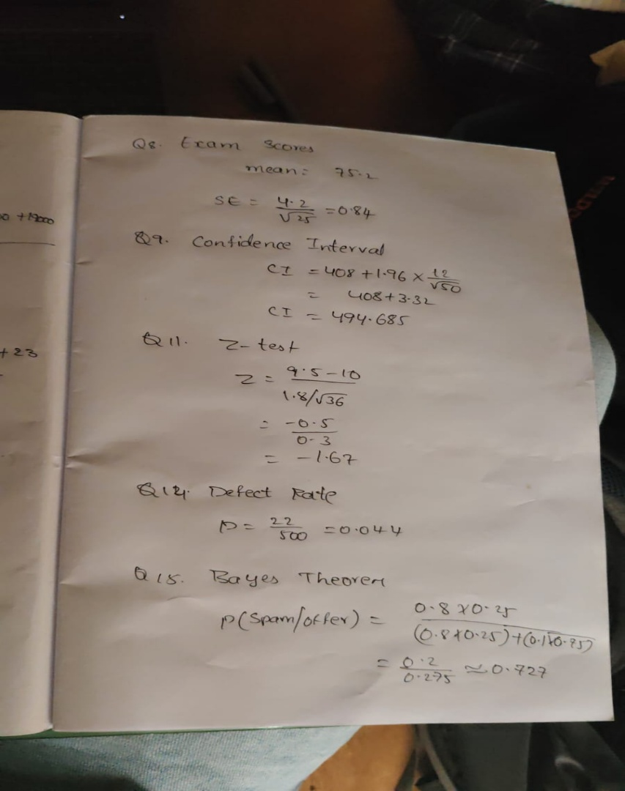

Problem 16: Disease Diagnosis
Given:
- Disease prevalence = 2%
- Test sensitivity = 95%
- Test specificity = 90%
Tasks:
- Compute the posterior probability of disease after a positive test.
- Explain why the result differs from 95%.

A probability distribution shows all possible outcomes and their probabilities.

It helps in:

Predicting future events

Making decisions under uncertainty

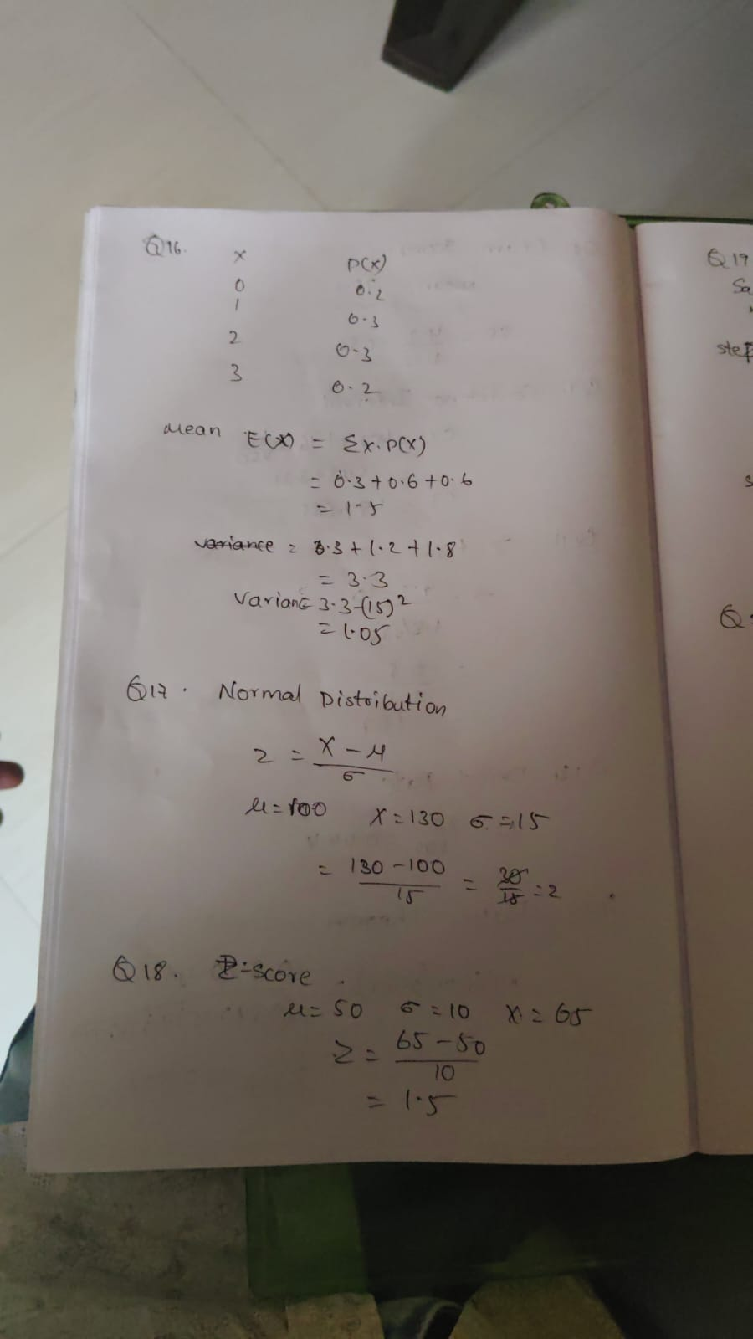

Problem 17: Website Conversion Rate
A company tests two landing pages.
Group | Visitors | Purchases
A | 5000 | 250
B | 5200 | 312
Tasks:
- Calculate conversion rates.
- Formulate hypotheses.
- Conduct a two-proportion z-test.
- Determine whether page B performs better.

A normal distribution is a symmetric bell-shaped curve.

Key properties:

Mean = Median = Mode

Most values are near the mean

It is widely used in statistics.



Problem 18: Mobile App Feature Test
Feature A:
- 400 users
- Average engagement = 18 min
- SD = 5 min
Feature B:
- 420 users
- Average engagement = 20 min
- SD = 6 min
Tasks:
- Test whether Feature B increases engagement.
- Calculate test statistic and p-value.
- Interpret results.

A Z-score measures how far a value is from the mean.

It helps:

Identify outliers

Compare different datasets



Problem 19: Recommendation System
A new recommendation algorithm increases click-through rate from 4.8% to 5.3%.
Sample size:
- Old system: 100,000 users
- New system: 100,000 users
Tasks:
- Test statistical significance.
- Calculate p-value.
- Discuss practical significance versus statistical significance.

Used to test assumptions about a population.

If the test statistic exceeds the critical value:
Reject null hypothesis

Otherwise:
Accept null hypothesis

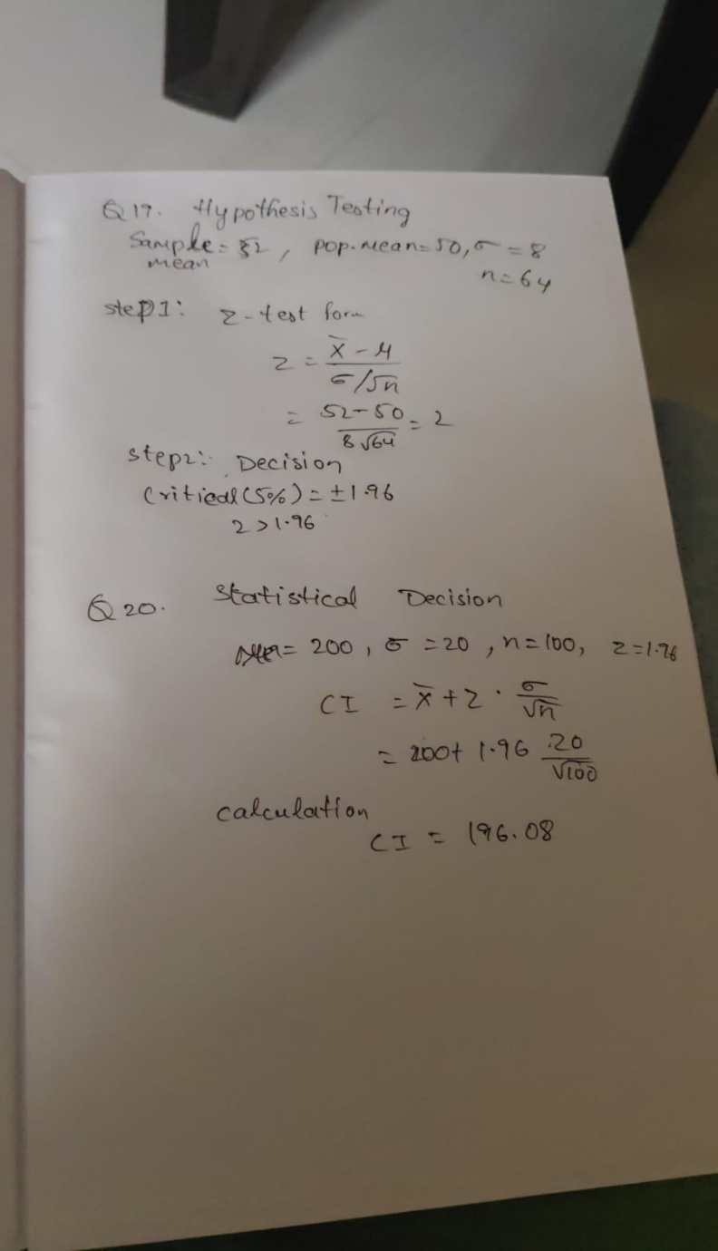

Problem 20: Salary Prediction Model
Two machine learning models produce Mean Absolute Errors (MAE):
Model | MAE
Model A | 4200
Model B | 4000
Across 50 test folds, the difference in MAE has:
- Mean difference = 200
- Standard deviation = 350
Tasks:
- Perform a paired t-test.
- Determine whether Model B significantly outperforms Model A.
- Explain the result in terms of statistical significance.

Statistical tools help in making better decisions.
Applications include:
- Business strategy
- Quality control
- Forecasting
Data-driven decisions are more accurate and reliable.

